FA 261X: Survey of Asian Art: India, China, and Japan Virginia Military Institute
Department of English and Fine Arts Spring 2013
MWF 0900-0950 Scott Shipp Hall 215 Dr. Jenny Ramirez
Office: Scott Shipp Hall 235-A Office hours: 1000-1100 MTWF and by appt.
Phone: 464-7484 (O), 540-456-6082 (H), 434-466-9509 (C) email: ramirezjo10@vmi.edu

COURSE DESCRIPTION: What defines a culture? How does art and architecture reflect cultural concerns and values? Are there differences in the way the East and West perceive and visualize their world? These and many more questions will be part of this study of Asian Art. As a Cultures & Civilizations course, FA-261X is designed as an introduction to the art and architecture of India, China, and Japan. Covering nearly 4,000 years of art and history produced by a massive area of the world—Southeast and East Asia—the course will present the main lines of development of these cultures and their arts. Emphasis will be placed on recognition and identification of major works of art, including sculpture, ceramics, painting, and architecture, and associated styles from each period/dynasty. A focus on religion and regional philosophy will be a strong component as well.

LEARNING OUTCOMES: By the end of this course, cadets will be able to demonstrate they have met the following course objectives:
- Cadets will learn to identify, discuss, and write effectively about the basic periods of stylistic development, specific artists and schools of art, and significant individual works of art and architecture in the countries of India, China, and Japan.
- Cadets will be able to identify specific Asian cultures and their arts and be able to distinguish them from other world cultures.
- Cadets will be able to discuss Asian art effectively in the contexts introduced during the course and gain a greater understanding and sensitivity to Asian art and cultures in general.

Core Curriculum Learning Outcomes: By the end of this course, cadets will be able to demonstrate they have met the following Core Curriculum learning outcomes:
- HIC-3: Appreciate a culture’s distinctiveness either through texts or experiential contact.
- HIC-6: Identify cultures of the world and the components and practices that distinguish them from others.
Required textbook: John LaPlante, Asian Art, 3rd edition; all other readings will be provided in class or on-line in Angel.

Course Grade will be calculated using the following percentages:
- Mid-Term Exam 20%
- Final Exam 20%
- Three Unit Projects (10% each) 30%
- Reflective Essay 20%
- ePortfolio 5%
- Participation/engagement/professor’s discretion 5%

COURSE REQUIREMENTS:
- Regular attendance: You must attend at least seventy percent of the class meetings in order to receive credit for the course. Note the Institute Policy on Class Absence:
A policy on maximum class absences was adopted. Under this policy, the maximum allowed percentage of class absences is 30%. No categories of absences (academic, athletic, guard, 3.0 cuts, etc.) will be exempt from that percentage. When a cadet reaches 20% absences, the instructor issues a written warning and the cadet must sign a receipt that he/she is aware of the absences incurred. Upon reaching 30% absences the cadet is referred to the Dean for appropriate action. Normally a cadet who exceeds the 30% absences will be required to withdraw from the course with a W or a WF.
For the purposes of this class, 30% equals a total of 12 absences from class for any reason, including absences accrued during the drop/add period. Therefore, in order to be eligible for a passing grade in this course, you cannot miss more than twelve class meetings, however legitimate your excuses.
2) Reading assignments: This course involves reading from the required textbook throughout the semester. The lecture schedule indicates what chapters should have been read by that date. In addition, various articles and excerpts from outside sources are listed. These additional readings will address specific issues of lecture topics in more depth and should be read by the corresponding class time. Be prepared to discuss these readings during class.
- Field Trip: All cadets will be required to visit the Sackler and Freer Gallery in Washington DC on Sunday, March 24th. We will tour the collection together and then you will have free time to do your own observing. Not only is it beneficial to see real art, not just reproductions, in a museum setting, but your 3rd unit project is tied to this trip so it is important that you attend. A bus will be reserved to transport you to the museum.

- Mid-term examination: The mid-term exam is worth 20% of the total grade. Exam questions are drawn largely from lectures and consist of object identification, short answer, and one essay. **Essay on the mid-term could serve as an artifact for the ePortfolio.

- Final examination: The final exam is worth 20% of the total grade. Exam questions are drawn largely from lectures and consist of object identification, short answer, and a cumulative essay.
6) Three Unit Projects: This course is divided into three main units of study. At the end of each unit, the completion of a project, which reflects ideas, concepts, and learning from that unit, will be required. Each project is worth 10% of the final grade. These are two-part assignments that require an object/design/image and an accompanying 2-3 page (500-750 words) typed description and summary of the project. See the attached “Unit Projects” pages for more details. **These projects could serve as artifacts for the ePortfolio.
A) Role-Playing Sculpture Project (Unit 1: Ancient Civilizations) includes imagining what it would be like to be an artist in ancient India, China, or Japan and creating an object that reflects societal values and beliefs. Unit 1 Project is due Friday, February 22nd during class time.
B) Sacred Space Design Project (Unit 2: Asian Religions and Art) includes designing a sacred space that responds to a religious, spiritual, or philosophical aspect of Asian culture. Unit 2 Project is due Wednesday, April 3rd during class time.
C) Gallery Object Project (Unit 3: Traditional India, China, Japan) involves choosing an artwork from the VMFA field trip and analyzing, researching, and writing about it. Unit 3 Project is due Wednesday, April 24th, during class time.
- Class Participation/Engagement: While this class is designed largely as a lecture course, I encourage class participation and conscientious engagement. 5% of the total course grade will come from overall class participation, in-class responses to assigned readings, and discussions of unit projects (see below).

- ePortfolio: As part of the requirements for a Cultures & Civilizations course, early on in the semester, cadets will establish and maintain an electronic portfolio. This ePortfolio can be used as a workspace throughout the semester, but ultimately, will be the final graded source of all that you have learned in this course and how you learned it.
Through analyzing visual art, reading, discussing, writing, and researching, you will collect a series of artifacts and you will store these artifacts in the ePortfolio. Artifacts can be essays from the mid-term exam, images and descriptions of the unit projects, in-class assignments, and other multi-media (audio, video, digital images, etc.) that demonstrate your learning and interests. Each artifact must have a Reflective Tag in which you briefly describe the substantive content of the artifact you have produced, reflect upon its significance in light of topics, themes, and issues raised by course lectures and readings, and why it was chosen as an artifact.
The Reflective Essay will be the final document comprising the ePortfolio. 5% of your total grade will be based upon meeting the deadlines for inviting me to view your ePortfolio, the chosen artifacts and their integration into the Reflective Essay, and the overall design and creative effort demonstrated.
ePortfolios must be set up, with at least two artifacts uploaded, and an invitation for me to view by Friday, February 8th. The final completed ePortfolio is due Friday, May 3rd. Cadets who fail to submit an ePortfolio and Reflective Essay will not receive Cultures & Civilizations credit for the course.

- Reflective Essay: As part of the requirements for a Cultures & Civilizations course, a 3-5 page, double-spaced, typewritten Reflective Essay will be written and is worth 20% of the final grade. In this culminating assignment, you are invited to think, reflect, and write about the connections between what you have completed in this course and what you have learned—and ultimately, how both have influenced you or your thinking about Asian culture. Artifacts should be used as evidence of your learning and must be referenced in your essay.
The Reflective essay will be due Friday, May 3rd. I will need a hard copy of the essay as well as the document uploaded into the ePortfolio. See the attached “Instructions for Students: Preparing to Write the Reflective Essay” and “Writing Prompt for the Reflective Essay” pages for more information. Also, see the attached “Revised C&C Rubric” page for details on how the ePortfolio and Reflective Essay will be graded and assessed.

Text and Web Resources:
This course is taught in a multimedia classroom using digital images via a PowerPoint format. All the images shown in class, including ones that you are responsible for on exams, will be available to you through Angel. Most of the images are also in the La Plante text. If you must miss class, whatever the reason, you are responsible for obtaining notes and reviewing the images. All course documents, announcements, and readings can be accessed on-line via Angel.

Academic Accommodations:
VMI abides by Section 504 of the Rehabilitation Act of 1973 and the Americans with Disabilities Act of 1990, which mandate reasonable accommodations be provided for cadets with documented disabilities. If you have a registered disability and may require some type of instructional and/or examination accommodations, please contact me early in the semester so that I can provide or facilitate provision of accommodations you may need. If you have not already done so, you will need to register with the Office of Disabilities Services, the designated office on campus to provide services for cadets with disabilities. The office is located on the 2nd floor of the VMI Health Center(Post Hospital). Please call or stop by the office of LTC Jones, Director of Disabilities Services, for more information, 464-7667 or jonessl10@vmi.edu.

Course Schedule
Unit 1: Ancient Civilizations: India, China, Japan

Week 1:
Wed, January 16 Introduction to course
Fri, January 18 Introduction to Asian art
Reading: LaPlante, ix-xv

Week 2:
Mon, January 21 NO CLASS (Inaugural Parade)
Wed, January 23 India: Indus Valley
Fri, January 25 China: Yellow River Valley
Reading: LaPlante, Chapt 1, 10

Week 3:
Mon, January 28 China: Shang Dynasty
Wed, January 30 China: Shang Dynasty
Fri, February 1 China: Zhou Dynasty
Reading: LaPlante, Chapt 11

Week 4:
Mon, February 4 China: Confucianism and Daoism
Wed, February 6 China: Qin Dynasty
Fri, February 8 China: Han Dynasty
*Invitation for me to view your ePortfolio sent by CAD
(ePortfolio should include initial set-up info and at least 2 artifacts)
Reading: LaPlante, Chapt 12; Excerpts from The Analects of Confucius and from the Dao de Jing

Week 5:
Mon, February 11 Japan: Neolithic Period
Wed, February 13 Japan: Yayoi Period
Fri, February 15 Japan: Kofun Period
Reading: LaPlante, 20, 21

Unit 2: Asian Religions and Art: Buddhism and Hinduism

Week 6:
Mon, February 18 Introduction to Buddhism
Wed, February 20 Early Buddhist Indian art: Maurya
Fri, February 22 Early Buddhist Indian art: Kushan
**First Unit Project due (Role-Playing Sculpture Project)
Reading: LaPlante, Chapt 2-3

Week 7:
Mon, February 25 Later Buddhist Indian art: Gupta
Wed, February 27 Spread of Buddhism to China: Three Kingdoms/Six Dynasties
Fri, March 1 Spread of Buddhism to China: Tang Dynasty
Reading: LaPlante, Chapt 4, 5, 13

Week 8:
Mon, March 4 Early Buddhist art in Japan: Asuka Period
Wed, March 6 Buddhist art in Japan: Nara Period
Fri, March 8 **Mid-Term Exam
Reading: LaPlante, Chapt 22

Week 9:
March 11-15 Spring Furlough

Week 10:
Mon, March 18 Introduction to Hinduism
Wed, March 20 Early Hindu art in India
Fri, March 22 Later Hindu art in India
Reading: LaPlante, Chapt 23, 6; Excerpts from the Mahabharata and the Bhagavad Gita

Sunday, March 24 *Required Field Trip to the Sackler and Freer Galleries, Washington, DC

Week 11:
Mon, March 25 Later Hindu art in India
Wed, March 27 Islam and the Mogul Dynasty
Fri, March 29 Islam and the Mogul Dynasty
Reading: LaPlante, Chapts 7-9; Excerpts from the Koran and from the Gita Govinda

Unit 3: Traditional China and Japan

Week 12:
Mon, April 1 NO CLASS (Easter Break)
Wed, April 3 China: Rise of secular painting
**Second Unit Project due (Sacred Space Project)
Fri, April 5 NO CLASS (I will be at a conference)
Reading: LaPlante, Chapt 14, 16

Week 13:
Mon, April 8 NO CLASS (Spring FTX)
Wed, April 10 China: Rise of secular painting
Fri, April 12 China: Song Dynasty
Reading: LaPlante, Chapts 17, 18; Excerpts from classical Chinese poetry

Week 14:
Mon, April 15 China: Song Dynasty
Wed, April 17 China: Yuan Dynasty
Fri, April 19 China: Ming Dynasty

Week 15:
Mon, April 22 Japan: Heian Period
Wed, April 24 Japan: Heian Period
**Third Unit Project due (Gallery Object Project)
Fri, April 26 Japan: Kamakura Period
Reading: LaPlante, Chapt 24, 25; Excerpts from Japanese poetry and The Tale of Genji

Week 16:
Mon, April 29 Japan: Kamakura Period
Wed, May 1 Japan: Kamakura Period
Fri, May 3 Summary/Review of Asian art
Reading: LaPlante, Chapt 26, 27
** Reflective Essay due CAD (one copy uploaded into ePortfolio and one hard copy due to me)
**completed ePortfolio with artifacts and Reflective Essay due; send invitation for me to view CAD

Thursday, May 9th, 1400-1700 *FINAL EXAM

----------------------------------------------------------------------------------------------------------------------------------

Key Periods and Dates

Neolithic (India, China, Japan) 4,000 - 2000 BCE

India: Maurya Dynasty 322 - 185 BCE
Shunga Dynasty 185 - 172 BCE
Andhra Dynasty 73 BCE – 50 CE
Kushan Dynasty 50 - 320 CE
Gupta Period 320 - 600 CE
Post-Gupta Period 500 - 900 CE
Early Medieval Period 900 - 1600 CE
Mogul Dynasty 1526 - 1857 CE

China: Shang Dynasty 1766 - 1045 BCE
Early Zhou Dynasty 1045 - 900 BCE
Middle Zhou Dynasty 900 - 600 BCE
Late Zhou Dynasty 600 - 221 BCE
Qin Dynasty 221 - 206 BCE
Han Dynasty 206 BCE - 220 CE
3 Kingdoms/Six Dynasties 220 - 589 CE
Tang Dynasty 618 - 907 CE
Northern Song Dynasty 960 – 1126 CE
Southern Song Dynasty 1127 – 1279 CE
Yuan Dynasty 1280 – 1368 CE
Ming Dynasty 1368 – 1644 CE
Qing Dynasty 1644 – 1912 CE

Japan: Yayoi Period 300 BCE – 300 CE
Kofun Period 300 – 600 CE
Asuka Period 552 – 645 CE
Nara Period 645 – 794 CE
Early Heian Period 794 – 897 CE
Late Heian Period 897 – 1185 CE
Kamakura Period 1185 – 1333 CE
Muromachi Period 1392 – 1573 CE
Momoyama Period 1573 – 1615 CE
Edo Period 1615 – 1868 CE

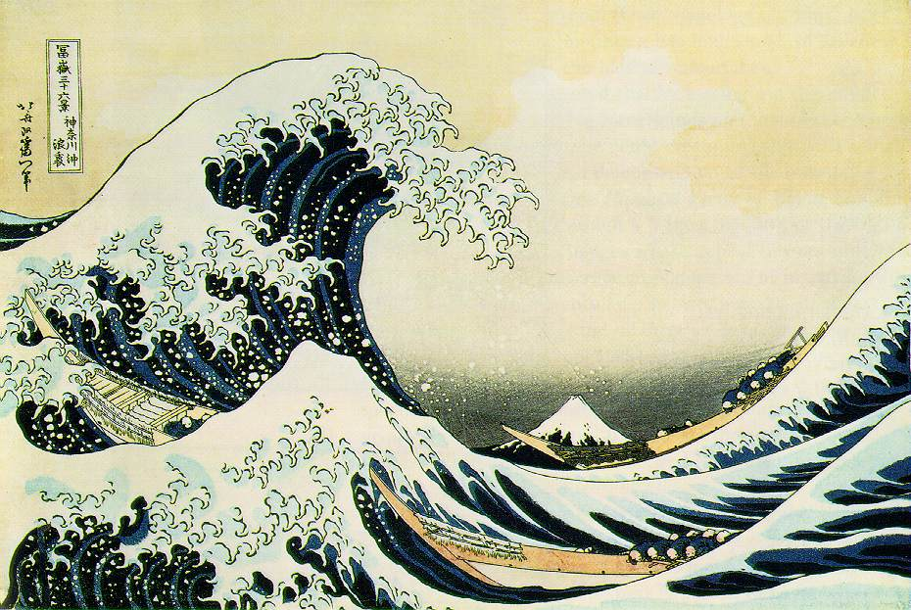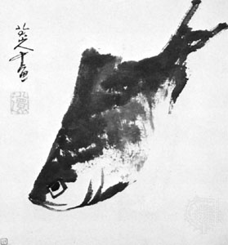
Hokusai, The Great Wave (Japanese) Zhu Da, Fish (Chinese)

UNIT PROJECT #1: Role-Playing Sculpture Project
Background: Having completed Unit 1 (Ancient Civilizations of India, China, and Japan), you now should have a basic understanding and recognition of the early forms of art that developed in India, China, and Japan. Furthermore, beyond the physical forms, you should be able to place these objects in a contextual framework (Who made it? Why? What was its function? Religious? Ceremonial? Utilitarian? Where would it have been located? Who would have used it?)
Assignment:
- Choose one of the three cultures (India, China, Japan) and pretend that you are an artist and have been commissioned to produce a particular sculptural object or are creating an object on your own.

- Think about what the function of the object will be and who asked you to make it or why you have decided to create it. Design the object. You may wish to sketch it out on paper first. Choose what form it will take, size, and materials. This object can be a vessel, tool, figurine, animal, or abstract form, but must be three-dimensional and must reflect characteristics and qualities that you have learned about from that particular culture. The size and materials are your choice.
3) Create the object. Here are some ideas:
- hand-built ceramic object made of play dough or modeling clay
- object carved out of a bar of soap or wax
- paper mache figure or mask
- paper, fabric, wood, leather woven or interlaced to form a sculpture
- Be creative!
I will provide various materials and tools such as clay, paint, soap, paper, and play dough. These will be available in Scott Shipp 209.
4) Write a 2-3 page (500-750 words) typed description of the object. In this summary, role play the part of the artist and your experience in the making of the object. Create a context for the piece. What is your position in this society? Who hired you to make it or why have you created this on your own? What is the function of the piece? Where would it be kept? How did you decide the materials? Size? Subject matter? What particular elements of the work reflect distinct characteristics of the chosen culture? How does the work reflect societal values and beliefs? Does the object have a practical function (bowl, weapon, tool) or is its function more aesthetic? ambiguous?

Grading: This project is due on Friday, February 22nd, during class time. You will need to complete both 1) the object, and 2) the 2-3 page typed description, and be prepared to discuss your object in class. I will not be grading the work on the actual execution of the object, but rather on the thought, concept, effort, and understanding of the culture in which you are representing.

UNIT PROJECT #2: Sacred Space Design Project
Background: Having completed Unit 2 (Asian Religions and Art), you now should have a basic understanding of the major religions that developed in India, China, and Japan. Much of the art, architecture, and sacred spaces were designed and built to support religious and spiritual functions. We have looked at and discussed examples of the sacred spaces of Buddhism, Hinduism, Shinto, and Muslimism.
Assignment:
- Design a space in which two or more of the major Asian religions can worship. This exercise is designed for you to analyze the commonalities and differences between major religions and their sacred spaces. Through this experience, you will also better understand how architectural spaces reflect the function for which they were made.

- Choose a particular culture in which this sacred space would be placed (India, China, or Japan).

- Your design can be a drawing, painting, 3D model, or computer-created plan. You can create an overall plan or aerial view, an interior view of a particular structure, an elevation of structures, or cutaway design. Please consider the setting for where the sacred space would be located.
4) Write a 2-3 page (500-750 words) typed profile of the sacred space that you have created. Your profile should focus on how the space was designed to support the two religions that you have decided to focus upon. It should include a general description, architectural design, location/geography/use of nature, symbolism and sacred objects within the space, and how it would be used by worshippers.
Other things to consider: What particular challenges did you have in combining two religions? Why were those religions chosen? Is this designed for large crowds or more individual worship? What types of materials, colors, textures, etc. would be used to actually build the space? Why did you choose an overall plan vs. an interior view? How important is actual space? How significant or not is symbolism? Numerology? Cosmology? Why would this design be particularly suited for the culture you’ve chosen?
Grading: This project is due on Wednesday, April 3rd, during class time. You will need to complete both 1) the design, and 2) the 2-3 page accompanying typed description, and be prepared to discuss your sacred space in class. I will not be grading the work on the actual execution of the plan/drawing, but rather on the thought, concept, effort, and understanding of the culture and religions in which you are representing.

UNIT PROJECT #3: Gallery Object Project

Background: Having completed much of Unit 3 (Traditional China and Japan) and developing a keen sense of the important forms of art that developed in India, China, and Japan from the 6th century forward, you should have a good understanding of the context and distinctive characteristics of each culture, as well as their similarities and commonalities.

Assignment: This project is based on a required field trip to the Sackler and Freer Galleries in Washington, DC on Sunday, March 24th. At the museum, you will choose one artwork in which to write your paper. It can be a painting, print, drawing, decorative art, or sculpture and it can be from any time period. However, the object must come from India, China, or Japan. Artworks from other Asian cultures, Korea, Tibet, or Nepal, for example, can be considered for this project but please obtain my approval first.

Choose something that appeals to you. Take notes on it at the gallery, thinking about the artist’s use of color, composition, space, line, materials, size, scale, texture, etc. What ideas are expressed? How do form and content work together? Be sure to write down the work’s size, date, and medium and any other information provided on the wall label. You should plan to spend at least 20 minutes observing the chosen artwork.

When you return to Lexington, you should start the second part of your paper project, which is research. Find out all you can about the work using scholarly resources, including its background, when and where it was created and why and for whom. Other important aspects of the work’s content and context are: What is its importance and meaning? How does it reflect the ideas of the period or culture that produced it? You can formulate a theory about the work, offer an interpretation of it, compare and contrast it to another work of art, or choose several works that have a common theme.
The following elements must be part of your paper:
- Illustration. Please include an illustration of the work. It can be in color or black-and-white. This is usually placed at the end of the paper before the bibliography.
- Bibliography. You should have AT LEAST THREE PRINT SOURCES (e.g. books and articles other than your textbook) to be used for your research. Include author, title, publisher, and publication date. If you intend to do supplemental research on the web, make sure your sources are reputable (e.g. those affiliated with museums, archives, or similar institutions). Acceptable internet material includes articles or excerpts from books that could also be found in print form - NOT information gathered from blogs, random non-scholarly websites, etc. Try starting with www.googlescholar.com. Any supplemental internet sources should be listed in your bibliography (as completely as possible citing author, article title, website/sponsor, date modified, date accessed by you).
- Citing Sources. Any information or ideas that you use from another source within the body of the paper, whether it is your textbook, a wall panel, a museum catalogue, a dictionary, the internet, or a monograph on an artist, must be documented with a parenthetical citation. This includes direct quotes but also paraphrasing ideas. Failure to cite your sources is considered plagiarism and violates the Honor Code at VMI. A good rule of thumb is that if something is not general knowledge (e.g., it would be found in any general information source) or you did not know it before you began your research, it should be cited.
- Formatting. Cadets must use Easy Access for documentation format when writing essays for courses in this department. Easy Access will demonstrate how to format the body of the paper (margins, spacing, etc.), citations, and the bibliography. Spelling, punctuation, grammar, and organization count, so please carefully proofread your paper before turning it in. Consider visiting the on-campus Writing Center for paper-writing assistance.
- Length and due date: This short research paper should be 3-5 pages in length and is due Wednesday, April 24th during class time.

*******************************************************************************************

Civilizations and Cultures Courses
Instructions for Students: Preparing to Write the Reflective Essay
As a student in a Civilizations and Cultures course, you have been asked to reflect on your learning experiences periodically throughout the semester. The goal of this approach—a theory of reflective learning advanced by 20th century educational philosopher, John Dewey—is to cultivate a habit of mind that enables you to articulate not only what you know, but also how you came to know it. In this culminating assignment, you are invited to write a reflective essay that will lead you to contemplate the connections between what you have done (e.g., assignments in the course) and what you have learned—and ultimately how both have influenced you or your thinking about the culture you have studied.
***********************
As you undertake the process of this final reflection, you’ll find it helpful to spend some time responding to the questions below which are designed to help you generate and discover a compelling and viable thesis/focus to develop in the reflective essay.
Step 1: As you reflect on the cultural communities you have been studying, take time to generate specific examples in response to each question below. Some might find it useful to make lists, map clusters of ideas, or write short paragraphs.
- What are the various cultural products, practices, and/or perspectives of this community (or communities)?
- What activities and assignments in the course have facilitated your learning about the culture(s)?

Step 2: Once you have generated some ideas in response to the questions above, decide what you believe to be the most distinctive feature of the culture(s). You may identify more than one distinctive feature of the culture(s) on which you’d like to focus. Or, you may identify a distinctive feature which changes over time. Remember that what makes a culture distinctive may be something that it has in common with another culture, or it may be something that makes it different than others. Which one(s) stand out as significant in your mind, and why? Your goal is to articulate what you have come to know about the culture(s) that you can present as significant in some way.
Step 3: With this distinctive feature (or features) in mind, identify the course activities and assignments (that you’ve collected as artifacts) which have informed and shaped your understanding of the culture(s) in this particular way. Consider these experiences in relation to one another. What thread of understanding of cultural products, practices, or perspectives might one or more of them serve to illustrate? These are the artifacts that you’ll present and analyze as you discuss the process of your learning, or how you came to understand the distinctive trait(s) of the culture you studied.
Step 4: By this point, you should have some sense of the ideas you’d like to present in the essay. After reading the formal writing prompt for the reflective essay assignment, try to express in a nutshell what you want to say in the essay, and why it’s worth saying. You could do this by writing down a couple of sentences or by talking with a classmate or your instructor. After you get some feedback to the ideas, you’re probably ready to start writing the initial draft of the essay.

Civilizations and Cultures Courses
Writing Prompt for the Reflective Essay
Common Assignment
Write a three- to five-page reflective essay in which you identify what you came to understand as the most distinctive feature of the culture(s). To develop and illustrate your focus for the essay, you should discuss the ways in which the activities and assignments you’ve selected as artifacts have informed and shaped your learning by making specific reference to them. Use the style of documentation (e.g., MLA, APA, or The Chicago Manual of Style) suggested by your instructor to clearly document references.

Requirements:
- The reflective essay should develop from a clear, compelling focus that is organized, thoroughly developed with relevant examples drawn from ePortfolio artifacts, cohesively structured, and expressed in clear, carefully edited sentences.

- For the reflective essay, you will draw on artifacts from a rich assemblage of work that you have created over the course of the semester. Though no minimum number of artifacts is required to be placed in the “showcase” ePortfolio and discussed in the reflective essay, you should have a sufficiently large number of completed assignments and activities in the “workspace” ePortfolio so that you may choose from among them to select those that help you advance and develop your thesis most effectively.

- The reflective essay will contribute to your final course grade. (The weight of the assignment will be determined by your instructor but must count a minimum of ten percent in all Civilizations and Cultures courses.) The assignment must be submitted by the last day of classes, which is the Institute’s deadline for submission of written work.

- Guidelines, training schedules, and other helpful information regarding the ePortfolio may be found on Angel. 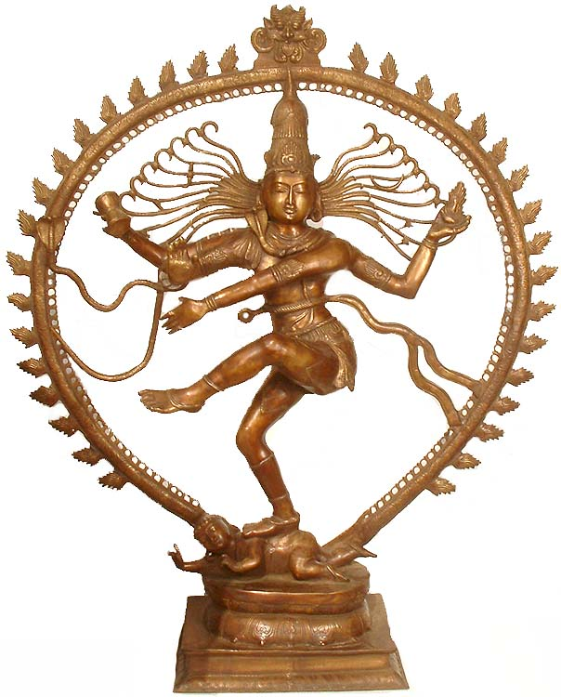 Shiva Nataraja (Indian)
 | UNDERSTANDING OF CULTURAL DISTINCTIVENESS | ANALYSIS OF ePORTFOLIO ARTIFACTS | REFLECTION ON LEARNING
“5” RATING | Advances a complex, insightful thesis/ focus for the essay that identifies distinctive components/ practices of the target culture(s) | Presents a complex, insightful analysis of a selection of substantive, varied, and revealing artifacts which fully support and develop the essay’s thesis/focus. | Meaningfully reflects on the relationship between what the writer learned about the target culture(s) and how the writer came to learn it through the ePortfolio process
“4” RATING | Advances an effective thesis/ focus for the essay that identifies distinctive components/ practices of the target culture(s) | Presents an effective analysis of a selection of relevant and varied artifacts which effectively support and develop the essay’s thesis/focus. | Thoughtfully reflects on the relationship between what the writer learned about the target culture(s) and how the writer came to learn it through the ePortfolio process
“3” RATING | Advances a clear thesis/ focus for the essay that identifies distinctive components/ practices of the target culture(s) | Presents a clear analysis of a selection of appropriate and varied artifacts, which loosely support and develop the essay’s thesis/focus. | Adequately reflects on relationship between what the writer learned about the target culture(s) and how the writer came to learn it through the ePortfolio process
“2” RATING | The thesis/ focus for the essay identifies distinctive components/practices of the target culture(s) but may be simplistic or stereotyped in thought. | A weak analysis, which may be attributed to a poor selection of artifacts either in terms of relevance, diversity, or quality. | Describes learning experiences
“1” RATING | Thesis/ focus for the essay does not identify distinctive components/practices of the target culture(s) and is unclear or fails to address the prompt. | Fails to include or discuss artifacts. | Does not discuss relevant learning experiences

